Guitar Manual
for Beginners

GUITAR PROS | SO YOU WANT TO BE A ROCK STAR?

TABLE OF CONTENTS
TABLE OF CONTENTS iii
So you want to be a Rock Star? v
Who this manual is for v
How this manual is organized v
General Advice v
Guitar Anatomy 3
Introduction 3
Supply List 3
Anatomy 4
Setting Up 9
Introduction 9
Setting up – The Amplifier 9
Changing your Strings 11
Tuning your Guitar 14
Different Kinds of Tunings 14
Tuning your guitar 14
Step 1: E String 15
Step 2: A String 15
Step 3: D String 15
Step 5: The B String 16
Step 6: Tuning the E String 16
Beginning to Play 21
Introduction 21
Understanding Tablature 21
Deep Purple -Smoke On the Water 22
Guitar Intro 22
Index 23
Sources 25

So you want to be a Rock Star?

Welcome, to ‘So you want to be a Rock Star?’
This manual is aimed at helping the beginner guitarist succeed in knowing what is and how to play, maintain, and advance his/herself in playing the guitar.

Who this manual is for
‘So you want to be a Rock Star,’ is for the new guitarist who has never played before and wants to learn how to get started.

How this manual is organized
- Chapter 1 – “Getting Started”
This chapter contains information on what you need to begin playing the guitar, including a list of items you will need.
- Supply List
- Guitar Anatomy
- Chapter 2 – “Setting Up”
This chapter contains necessary information to get your instrument ready to play and correct positioning.
- Changing your strings
- Tuning Your Strings
- Proper Practice Space

- Chapter 3 – “Beginning to Play”
This chapter contains the knowledge you will need to play your first song.
- Understanding tablature
- Tablature: Deep Purple – Smoke on the Water

General Advice
The Internet is a great source of information. If you have any musical inspirations, learn more about them and their techniques. If you have any favorite songs, look up the tablature and try to play them along with the song. There is no wrong way to play the guitar and bass. Experiment and practice, this lead you a sound that is in your own.

Guitar Anatomy
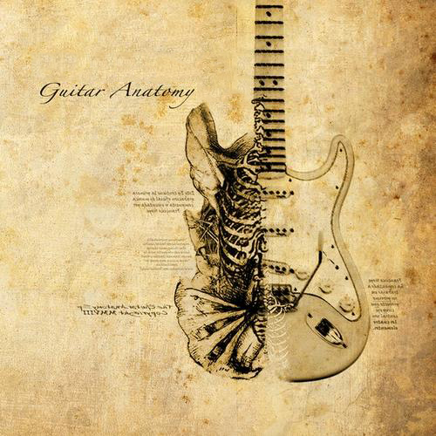

Guitar Anatomy

Introduction
Your guitar has a body and organs inside and outside of it that makes it useful. Learn the outside body so that the rest of this manual is easily referenced to later on. This is one of the most important sections in the Chapter. Each model and brand of guitar is different. Yours may feature items not on the list or may even have extra features that haven’t been included. Some guitars have more than 6 strings. Some Bass Guitars have more than 4 strings. Others may be fretless. These are advanced instruments that we will not cover in this book, but you may feel free to study more about them using the internet or other resources.

Supply List
- Guitar
- Amplifier – For electric Instruments
- Amp Cable – Long enough to play comfortably
- Guitar Stand – So that the neck of your guitar is never bent
- Note Stand – This will save your back a lot of pain
- Spare Strings – You will need these eventually
- Tuner – Use an electric tuner or tune by ear
- Guitar Pick – Optional, some guitarists play without picks
- Metronome – To help you keep a beat
- Strap – If you plan to play standing up
- Recorder or Looper – If you plan to record your progress
- Wire Cutter – to help trim new Strings

Anatomy

- Headstock
- Tuners or machine-heads
- Truss-rod cover
- Nut
- Fingerboard or fretboard
- Frets
- Position Markers (inlay)
- Neck
- Strap Button
- Cut away
- Pickguard
- Neck (Rhythm) Pickup
- Pickup Selector Switch
- Bridge (Lead) Pickup
- Bridge
- Tailpiece
- Volume/Tone Controls
- Body
- Strap Button
- Jack Port

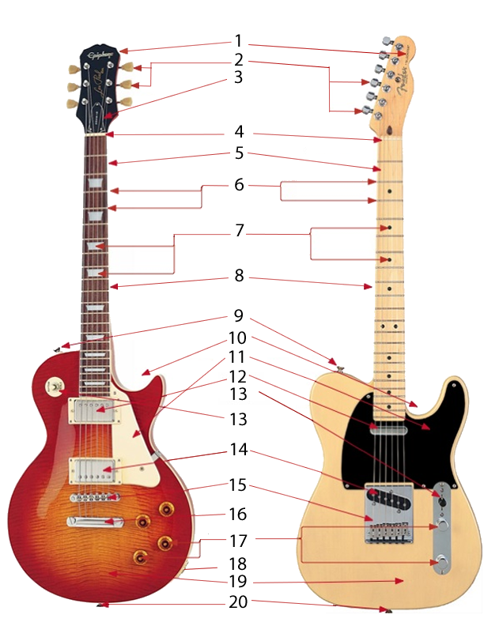

Setting Up

Setting Up

Introduction
It’s important to have an organized practice space. A comfortable practice area insures peace and tranquility as you play. Malfunctioning equipment, broken wires or strings are all issues you may face. This section of the manual will help you understand what the items are needed to get started to play your first song.

Setting up – The Amplifier
Caution: Consult the owner’s manual for your specific Amplifier to avoid harming it

- Plug in the Power to your Amplifier
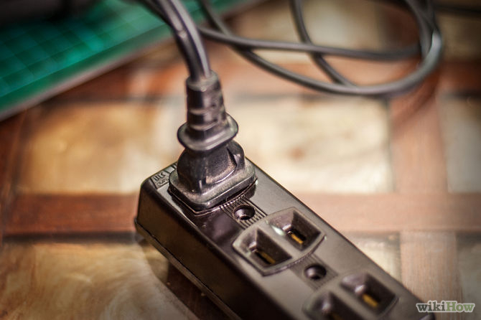
- Plug in your Guitar Cables to your Guitar Jack Port
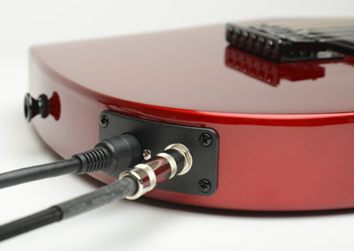
- Plug in your Guitar Cables to your Amplifier
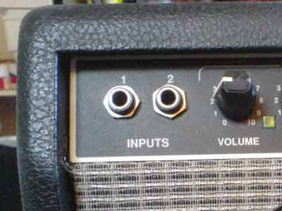
- Twist your Tone/Volume control down to 0 on your Guitar and Amplifier before you turn on the Power to your Amplifier
- Turn on the Power Switch for your amplifier
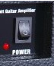
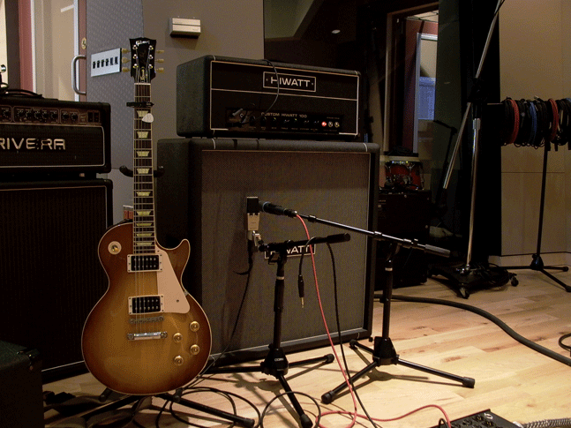
- End result – You will be able to hear yourself play through your Amplifier

Changing your Strings
Before changing your strings you should learn a few things about different gauges of strings. For a deeper darker tone you should get thicker gauged strings and for a lighter tone you should get thinner strings. There are advantages in price, tonality, and maintenance depending on which kind of strings you prefer and it is an interesting process to learn about through other resources besides this manual.
- Obtain appropriate Strings for your Guitar
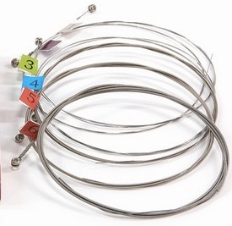
- Remove your old strings by loosening the Tuners or Machine-Heads
- You can do this by hand or by using a specialized tool-
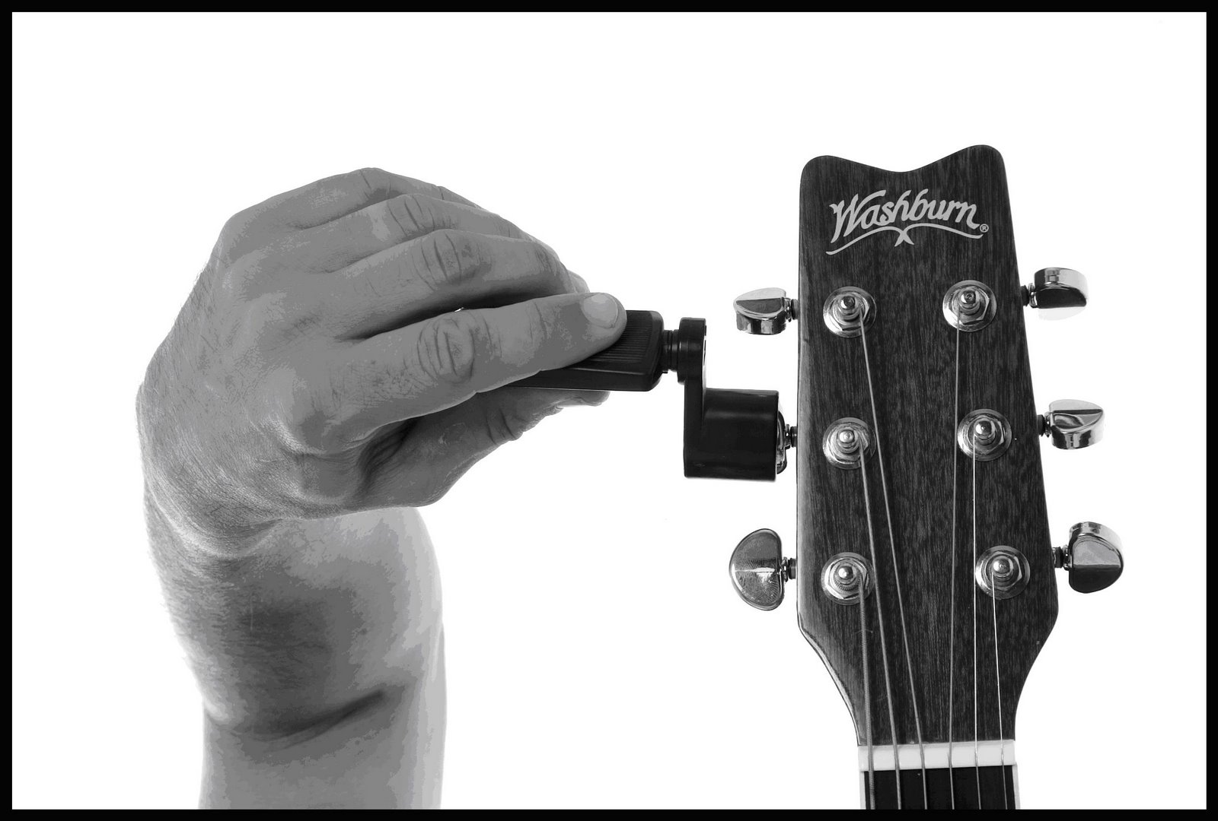
- Guide your old strings off the Tuners and down the Neck of the Guitar
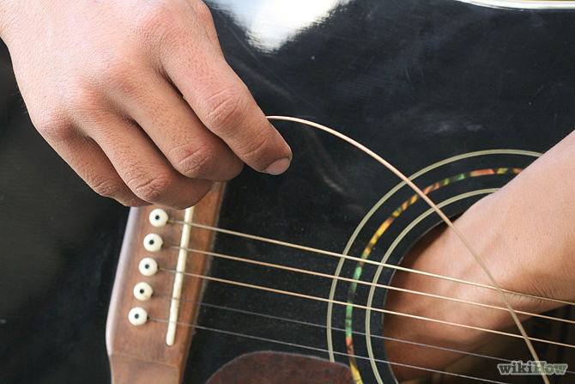
- Carefully remove the old Strings from the port at the Base of your Guitar
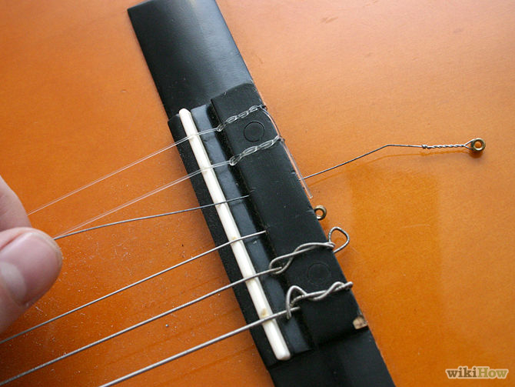
- Insert your New strings through the same Port you removed the old Strings
- Lead your new Strings up the neck and up to the Tuners or Machine-Heads
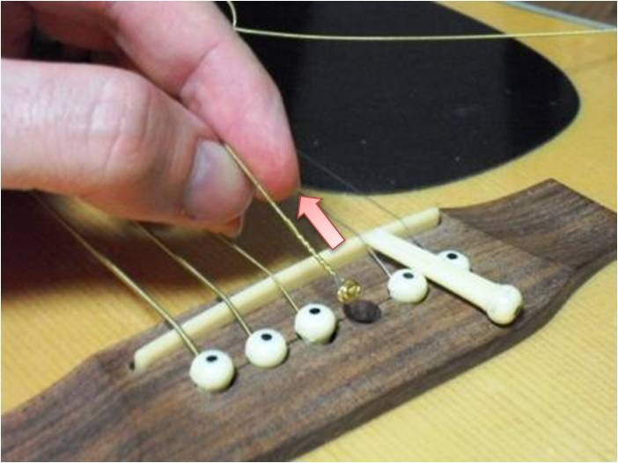
- Tie your new strings around the appropriate Tuners
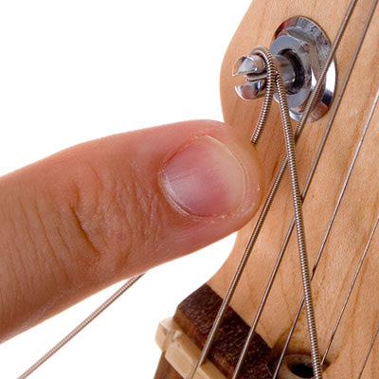.
- Tighten your new Strings using the Tuners or Machine Heads
- Remove the extra length of string dangling leftover from the Tuner suing a Wire Cutter
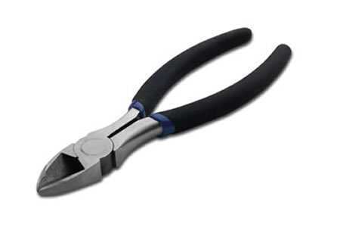

Tuning your Guitar
Congratulations on restringing your instrument! Now you’re in the last step towards playing your first song. It’s time to tune your instrument. There are many Variations of tuning that you can choose from. You will need to find a Tuner or tune by ear in order to use this section.

Different Kinds of Tunings
Standard Tuning is considered EADGBE for Guitar and EADG for Bass
Other Variations include
- C Tunings
- C. – E, C, G , E, C, G
- C6th. – E, C, A, G, E, C
- C7th – E, C, A, G, E, C, Bb
- C9th. – D, C, Bb, G, E, C#
- C#m. – E, C#, G#, E, C$, E
- D Tunings
- D9th. – E, C, A, F#, D, A
- E Tunings
- E high bass. – E, B, G#, E, B, G#
- E high inversion – G#, E, B, G#, E, B
- E low bass. – E, B, G#, E, B, E
- Em. – E, B, G, E, B, E

Tuning your guitar
Tuning the guitar is vital to sounding good. Here are some simple instructions that explain guitar tuning basics. The open strings of a guitar from the thickest to thinest are as follows:
- E – the thickest or lowest sounding string is known as the 6th string
- A – is the 5th
- D – is the 4th
- G – is the 3rd
- B – is the 2nd
- E – the thinest or highest is the 1st

Step 1: E String
Tune the bottom E, as accurately as you can. Chances are it’s in tune anyways, being the thickest string it’s the least likely to detune itself than any of the others. If you have another instrument you can tune it by using that. If you have no device or instrument handy just try to get it as accurate as possible, what really counts when you are playing is that the guitar is in tune with itself and any other instruments you might be playing with.

Step 2: A String
Place the first finger of your left hand just behind the fifth fret on the bottom E string. That’s an A note. Keep your finger on that fret. Now pick the fifth and six strings in turn, gently adjusting the fifth string tuning peg until the two notes are the same.
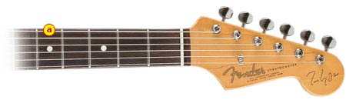

Step 3: D String
Place the first finger of your left hand just behind the fifth fret on the A string. That’s a D note. Tune the 4th string (the D note) to that.
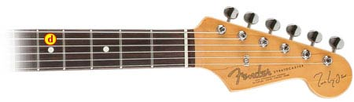

Step 5: B String
Place the first finger of your left hand just behind the forth fret (note the B string is the only one that comes from a different position the forth fret, the rest are from the 5th fret).
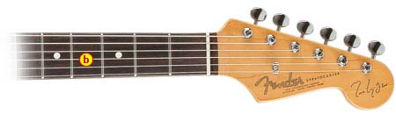

Step 6: E String
Place the first finger of your left hand just behind the fifth fret on the B string. That’s a E note.
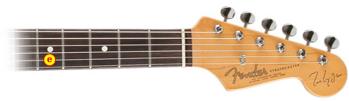

Beginning to Play

Beginning to Play

Introduction
You have successfully set up your practice space, tuned your guitar, and are in a comfortable position to play your first song. Before we get to the actual notes we will have to learn how to read those notes to know how to play the song. After that we will cover the song and at the end include some practice advice.

Understanding Tablature

Proceed from left to right. Tabs are read like sentences in a book - read them from left to right, across the page, dropping down to the next line only when you've reached the end of the previous. Play the notes and chords in sequence as you read them from left to right. The numbers simply represent the fret the tab is telling you to play.
- Note that most (but not all) tabs don't display the rhythm with which you should play the notes in the tab.
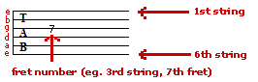
When the number "0" is used in tablature, this indicates that the open string should be played!
The numbers simply represent the fret the tab is telling you to play. 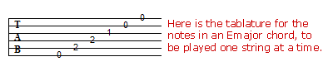
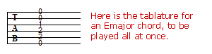

Deep Purple -Smoke On the Water

Guitar Intro

Key:
o = marks the beginning and end of the measure
() = let it ring

E||-----------------|---------------|----------------|------------------||
B||o----------------|---------------|----------------|-----------------o||
G||--0---3---5----0-|---3---6-5-----|-0---3---5----3-|---0----(0)-------||
D||--0---3---5----0-|---3---6-5-----|-0---3---5----3-|---0----(0)-------||
A||o----------------|---------------|----------------|-----------------o||
E||-----------------|---------------|----------------|------------------||

Index

Amp Cable, 3
Amplifier, iii, 3, 9, 10
Body, 4
Bridge, 4
Cut away, 4
Fingerboard, 4
fretboard, 4
Frets, 4
Guitar, iii, v, 7, 3, 9, 10, 11, 12, 14, 18
Guitar Stand, 3
Headstock, 4
Jack Port, 4, 9
Looper, 3
machine-heads, 4
Metronome, 3
Neck, 4, 12
Note Stand, 3
Nut, 4
Pickguard, 4
Pickup Selector Switch, 4
Position Markers, 4
Power, 9, 10
Recorder, 3
Spare Strings, 3
Strap, 3, 4
Strap Button, 4
Strings, iii, v, 3, 11, 12, 13
Tailpiece, 4
Truss-rod cover, 4
Tuner, 3, 13, 14
Tuners, 4, 11, 12, 13
Volume/Tone Controls, 4
Wire Cutter, 3, 13

Sources
- http://guitarless.com/2009/11/guitar-101-anatomy-the-basics/
- http://www.justinguitar.com/en/BC-104-GuitarAnatomy.php
- http://www.fanpop.com/clubs/music/images/7294367/title/electric-guitar-wallpaper
- http://www.musiciansfriend.com/guitars/b.c.-rich-metal-master-warlock-electric-guitar/512675
- http://deviantartgear.deviantart.com/art/Fangs-T-Shirt-337772495
- http://www.cartownforums.com/forums/downloads/car-town-template-resources-70/pink-flames-873/
- http://www.mfactorgames.com/uccs/guitar_gear_2010.png
- http://userserve-ak.last.fm/serve/500/46477261/Guitar+Anatomy+Vol1.jpg
- http://www.about-guitar-amps.com/images/input_jacks.jpg
- http://pad2.whstatic.com/images/thumb/6/6a/Change-Guitar-Strings-Step-3Bullet1.jpg/670px-Change-Guitar-Strings-Step-3Bullet1.jpg
- http://www.pluckandplayguitar.com/image-files/string-in.jpg
- http://0.tqn.com/d/guitar/1/5/n/r/DSC_2355.jpg
- http://www.flickr.com/photos/90076212@N06/9284424417/

