10 tips for a successful college experience
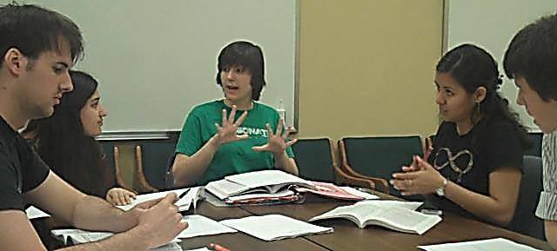
- Attend and participate in every class
- Visit professors during their office hours
- Refer often to your course syllabus
- Ask questions
- Use a planner
- Attend campus events join organizations
- Prepare thoroughly for exams and assignments
- Start a study group
- Keep an open mind
- Use your campus resources
For more information contact: The Learning Center
www.unt.edu/lc (940) 369-7006 University Union, Suite 323
The Learning Center offers academic assistance by:

• Helping you understand your learning style
• Connecting you with FREE tutors (one-on-one, group, and online)
• Offering workshops (time management, note taking, test taking strategies, test anxiety, and speed reading)
• Offering learning assistance books, videos, and computer instruction
• Offering exam preparation materials (CPA, CLEP, ExCET, GMAT, GRE, LSAT, MCAT, and TOEFL)
• Connecting you with other campus resources

