10 Tips for a successful college career

For more information contact:
The Learning Center
www.unt.edu/lc
University Union, Suite 323
(940) 369-7006
- Ask questions
- Keep an open mind
- Use your campus resources
- Refer often to your course syllabus
- Visit professors during their office hours
- Attend and participate in every class
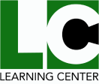
- Use a planner
- Start a study group
- Attend campus events and join organizations
- Prepare thoroughly for exams and assignments

