Unethical Advertiser: MEXX

http://childhealthsafety.wordpress.com/graphs/
This article provides interesting speculation at the ethnicity of empirical data that vaccines provided to African Children are not as efficient as other forms of aid.
“These children need proper food, clean water to drink and wash in and sanitation. We give them vaccines instead.”
Small-Pox Epidemics, Cost, and Fatality Rates Compared
 | Vaccinal Condition | Small-Pox Cases | Small-Pox Deaths | Fatality-rate Per Cent | Cost of Epidemic
London 1900-02 | Well Vaccinated | 9,659 | 1,594 | 16.50 | £492,000
Glasgow 1900-02 | Well Vaccinated | 3,417 | 377 | 11.03 | £ 150,000
Sheffield 1887-88 | Well Vaccinated | 7,066 | 688 | 9.73 | £32,257
Leicester 1892-94 | Practically Unvaccinated | 393 | 21 | 5.34 | £2,888
Leicester 1902-04 | Practically Unvaccinated | 731 | 30 | 4.10 | £1,602

Practically unvaccinated patients fatality rates decrease, the cost of the epidemic is far less, and the number of small pox cases in also far less.
Keep in mind, that Leicester is a much smaller population and not as densely populated as London or Glasgow. People living closer to one another carry the greater risk of
In fact, this website provides plenty of sources to confirm that is true.
http://www.uniteforsight.org/global-health-university/urban-rural-health#_ftnref20
“There is an underlying assumption that urban populations will be healthier than their rural counterparts and that urbanization equates with modernization. However, this is rarely true. Research about the features of urban areas that influence health has been relatively sparse but often indicates increased health hazards.(20)”
Judd FK, Jackson HJ, Komiti A, Murray G, Hodgins G, Fraser C. High prevalence disorders in urban and rural communities.Aust N Z J Psychiatry. 2002;36:104–113.

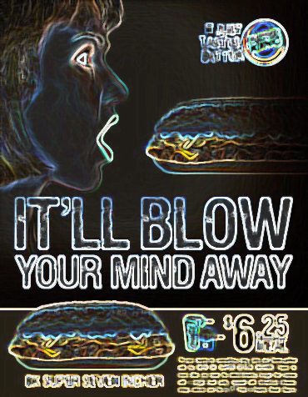
Another unethical graphic is this Burger King sandwhich ad which displays an innuendo for oral sex rather than out right displaying it. For a restaurant that sells toys to children and has playground areas designated for the kids, this kind of advertising needs to be heavily scrutinized. Kids will be influenced by Burger Kings ads when they visit and this isn’t the message you want to give off when you are eating from there. It’s gross, tacky, and overall unethical. Burger King has a history of controversial ads including the “I Am Man” Commercial.

